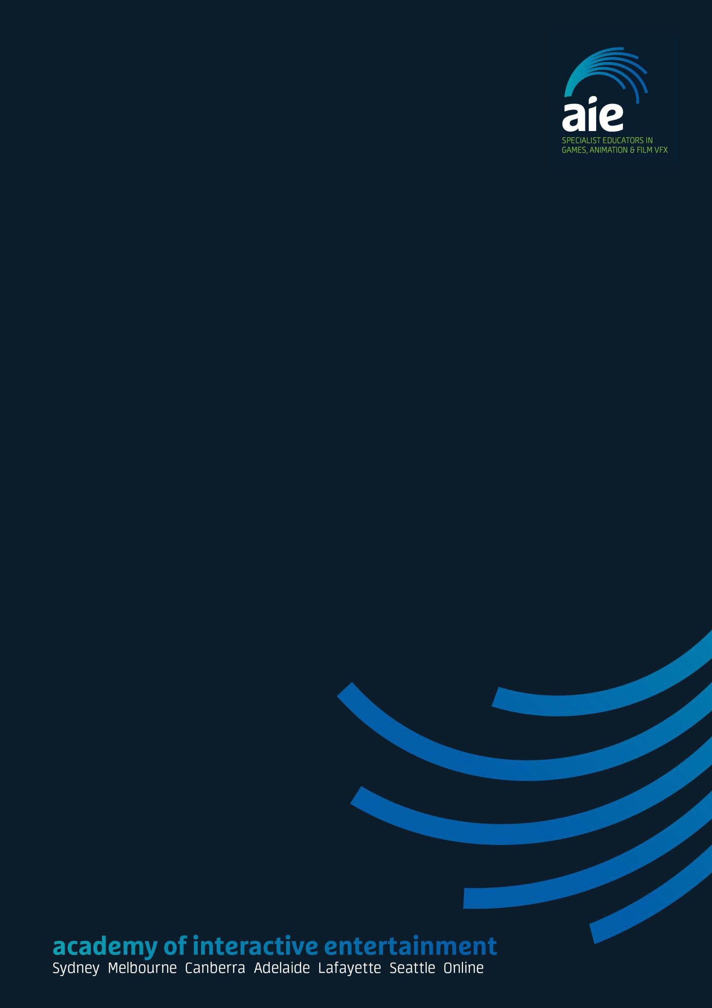

**Professional Practice Development**

Name

Diploma of Screen and Media

Stage 1 - Overview

# 

Professional Practice Development



"A journey of a thousand miles begins with a single step"

Lao Tzu

Task 01 - Introduction

# **of Contents**

Let’s start off with the very first task of the journal. This is mainly to introduce yourself and see what your thoughts are regarding what you want to achieve and what your long terms goals may be.

You will benefit most from this reflection if you take the time to answer as in depth and honestly as you can. Do not work through this at the last minute or only spend a short amount of time on it as we will be reviewing this first task towards the end of the subject.

As with any assessment, the more honest your responses, the more valuable the information gained from it will be. Keep in mind the following points:

* This is a ‘point-in-time’ snapshot of your ideas, strengths and limitations. Over this next year your skills will change, you will change and so will your strengths and limitations.
* Everyone is a novice at some time. Even people who later become experts.

|  |
| --- |
| *Note: You will no doubt need to adapt and change your plans as opportunities present themselves. Regardless, this exercise is primarily meant to serve as a starting point and a reference for your future plans. We don’t expect you will have a high level of mastery in every area, so these questions will allow you to reflect on where your skills are at this moment in time.* |

Name

|  |
| --- |
| Jacob Bloem |

Any interesting work experience, voluntary or paid?

|  |
| --- |
| I make and deliver pizzas for work |

Any other achievements? Creative/artistic/leisure/sports?

|  |
| --- |
| Currently a competitive laser tag player. Going into my 3rd nationals |

Hobbies and interests?

|  |
| --- |
| Laser tag, gaming. |

Why did you decide to study a diploma and why AIE?

|  |
| --- |
| I enjoy games and want to make my ideal dame. AIE just seemed like a good choice. |

What do you want to achieve from studying at AIE?

|  |
| --- |
| Enough skills to make my way in the industry |

What are your long term career goals?

|  |
| --- |
| I want to push game design away from its current direction that keeps producing potentially good games that get ruined by the “profitable business model” known as loot boxes and micro transactions. Good games with a decent story and polished gameplay sell. |

What plans do you need to put in place for you to get there?

|  |
| --- |
| While working in the industry I will slowly make my own minor games that will all link in together and produce a large production based on these when I can gain some backing. |

What do you enjoy/dislike the most and why? (state at least one of each)

|  |
| --- |
| I don’t like games that are braindead to play. When the strategy and the task are so simple and repeated it doesn’t feel fresh every time you play.  I enjoy strategy and things that make me think, if I can engage my brain as fully as possible in the task in front of me, I find that enjoyable. |

What are your study/skills development goals this year and how will you achieve them?

|  |
| --- |
| I want to have a solid understanding of code and be able to produce a decent play area in my games. |

Describe your learning you have undertaken so far at AIE?

|  |
| --- |
| Plenty of hands on work that has kept me interested in the course. I have trouble keeping my attention fully focused on talks and lectures so this is a good system for me. |

What has been good and bad about the experience?

|  |
| --- |
| Its good that someone who has experience in the field is teaching us as they know the pitfalls better than any textbook instructor/teacher.  While there is lots of hands on work, there are also long periods of time where its all just talk and lectures. |

How might you approach the learning differently to help achieve your goals for the year?

|  |
| --- |
| I should take a more proactive approach and find materials that offer a different point of view. |

What will people around you see as your weaknesses or challenges you need to overcome?

|  |
| --- |
| My organization and focus need improvement. While I know how to set up a solid organized system I don’t find it easy to follow these systems as I like to improvise. |

What will people see around you as your strengths?

|  |
| --- |
| Persistence. If I have a task ill keep trying till I get it. |

What is meant by soft skills?

|  |
| --- |
| Personal attributes that enable someone to interact effectively and harmoniously with other people. |

Do you feel it is important to develop them? Why?

|  |
| --- |
| It is important to develop them. Communication makes a team function. A group of people working together towards a single goal is a team. People don’t get far without a team. |

Describe your soft skills? Where are your strengths and limitations?

|  |
| --- |
| I usually tell people what I’m thinking with full honesty. I feel this is an important skill to have because it leaves no room for assumption. It can however be detrimental because often I speak my mind before considering how it will affect the person. I’m also an introvert. I will probably avoid talking directly to people if I can. |

What are your negative work habits that prevent you achieving your goals?

|  |
| --- |
| I find it hard to focus a lot of the time. |

Research and define your understanding of the terms artist and artisan?

|  |
| --- |
| An artist creates a product of pure expression. An artisan puts the same care into their work, yet their products tend to have a function. |

Describe which fits most closely with your goals and why?

|  |
| --- |
| Artisan. Primarily because I want the products I produce to teach things that my generation could quite easily lose sight of. Fulfilling this function will be the core goal of my products. |

Task 02 – Teacher feedback

# **of Contents**

This task will allow you to seek feedback from your teacher around your professional development so far. It is a great opportunity to discuss the directions you may be interested in and seek advice on potential career opportunities or further professional development you may need to explore.

Organize a feedback session with your teacher and discuss the following points. Take notes, so that you can document this first feedback session along your journey.

|  |
| --- |
| *Note: Again, you may not have defined exactly what your goals are, so discuss your current thinking and see if this helps with any further direction. This is a snap shot of your current thoughts and ideas and may change along the way the more your skills develop and the more your knowledge of opportunities and the industry develops.* |

Discuss soft skills and how they are regarded in the industry?

|  |
| --- |
|  |

Discuss further the idea of artist and artisan and how it relates to your career goals?

|  |
| --- |
|  |

Discuss any areas in your skills so far which you feel need development?

|  |
| --- |
|  |

Discuss a potential plan for developing these skills?

|  |
| --- |
|  |

Discuss your long terms goals and seek advice for developing skills for these goals?

|  |
| --- |
|  |

Discuss potential opportunities and directions for reaching these goals?

|  |
| --- |
|  |

Summarise how this feedback session has helped you in moving forward with developing your skills?

|  |
| --- |
|  |

Finally, discuss how you might overcome the main challenges to your success for this year?

|  |
| --- |
|  |